Sliding Fee Discount Program and Financial Assistance Policy
At Family Solutions, we are committed to providing accessible mental health services to individuals who may face financial challenges, including uninsured and underinsured individuals. All patients seeking healthcare services at Family Solutions are assured that they will be served regardless of their ability to pay. Not one is refused service because of a lack of financial means to pay. Family Solutions will not discriminate based on an individual’s ability to pay, or whether payment for those services would be made under Medicare, Medicaid, or the Children’s Health Insurance Program (CHIP). The Federal Poverty Guidelines are used in creating and annually updating the sliding fee schedule to determine eligibility. We have developed a Sliding Fee Discount Program and Financial Assistance Policy to ensure that our services remain affordable and available to all members of our community. This program and policy apply to outpatient therapy being provided by Family Solutions. This program aims to assist individuals and families with limited financial resources in accessing the mental health care they need. This policy and program became effective on May 20, 2023.
1. Sliding Fee Discount Program:
Our Sliding Fee Discount Program offers reduced fees for eligible individuals and families based on their income and household size. The program operates on a sliding scale, where the fee is determined as a percentage of the standard fee and adjusted according to the participant's ability to pay. The following guidelines outline the eligibility criteria and fee structure:
For those at or below 200% of the Federal Poverty Guidelines, only family size and income can be used for consideration of approval. We do not require patients to apply to Medicaid/health insurance or do asset testing to qualify for the sliding fee discount program. Clients that are approved for the program have the option to reapply after the 12 months have expired or anytime there has been a significant change in family income. When the applicant reapplies, the look back period will be the lesser of six months or the expiration of their last Sliding Fee Discount Program application.

1.1 Eligible Criteria:
To qualify for the Sliding Fee Discount Program, individuals and families must provide proof of income and meet the predetermined income guidelines. The only factors used for consideration are household size and annual income. For those above 200% of the federal poverty guidelines, exceptional circumstances that may affect the individual or family’s financial situation may be considered.

- Family is defined as: a group of two people or more (one of whom is the householder) related by birth, marriage, or adoption and residing together; all such people (including related subfamily members) are considered as members of one family. Family Solutions will also accept non-related household members when calculating family size.
- Income includes gross wages; salaries; tips; income from business and self-employment; unemployment compensation; workers' compensation; Social Security; Supplemental Security Income; veterans' payments; survivor benefits; pension or retirement income; interest; dividends; royalties; income from rental properties, estates, and trusts; alimony; child support; assistance from outside the household; and other miscellaneous sources.
- Income Verification: Applicants may provide one of the following: last 2 paycheck stubs for each adult working in the household, a statement from employer (signed, dated on company letterhead) stating rate of pay, average number of hours worked per week, and hire date for each adult working in the household, unemployment benefit letter, Social Security benefit letter showing current monthly payment, last (current) federal tax returns or quarterly tax statement if self-employed, verification of Workers Compensation Insurance benefits, Military family allotment verification, payment made from trust or estates verification, documentation of child support (divorce papers, letter from Recovery Services), Copy of pension/retirement benefits, 1040 or W-2 statement due to loss of employment, or a Self-declaration of income.
- Uninsured – Individuals with no private health insurance, Medicare, Medicaid, state Children’s Health Insurance Program, state-sponsored, other government, or military health insurance coverage.
- Underinsured – Individuals with public or private insurance policies that do not cover all necessary medical services, resulting in out-of-pocket expenses that exceed their ability to pay.
- Refusal to Pay: If a patient verbally expresses an unwillingness to pay or vacates the premises without paying for services, the patient will be contacted in writing regarding their payment obligations. If the patient is not on the sliding fee schedule, a copy of the sliding fee discount program application will be sent with the notice. If the patient does not make an effort to pay or fails to respond within 60 days, this constitutes refusal to pay. At this point in time, Family Solutions can explore options not limited to, but including offering the patient a payment plan, waiving of charges or sending letters/invoices notifying patients of the amount of fees that are owed.
- Waiving of Charges: In certain situations, patients may not be able to pay the discount fee. Waiving of charges must be approved by Family Solutions designated official. Any waiving of charges should be documented in the patient’s file along with an explanation.

1.2 Fee Structure:
The Sliding Fee Discount Program fee structure is determined as a percentage of the standard fee based on the participant's income level and household size. The exact fee percentages are calculated and updated annually to reflect changes in the Federal Poverty Guidelines. The fee percentages for different income levels are as follows:
- Income Level 1: 0% of the standard fee
- Income Level 2: 20% of the standard fee
- Income Level 3: 40% of the standard fee
- Income Level 4: 60% of the standard fee
- Income Level 5: 80% of the standard fee
- Income Level 6: 100% of the standard fee
Participants will be assigned to the appropriate income level based on their income and household size, ensuring fair and equitable access to services.
2. Sliding Fee Discount Program Policy
For individuals and families that are unable to afford the cost of services, we offer a Sliding Fee Discount Program to offer discounted fees. This policy provides an opportunity to further reduce or waive the fees based on their financial situation. For those above 200% of the Federal Poverty
Guidelines, the Sliding Fee Discount Program Policy considers extenuating circumstances, such as extraordinary medical expenses, unemployment, or other hardships that may impact an individual’s ability to pay.
2.1 Application Process:
To apply for financial assistance, individuals must complete a confidential Sliding Fee Discount Program Application which includes providing supporting documentation of their financial status. The completed form will be reviewed by our designated committee, which assesses the individual's financial need and determines the appropriate level of assistance. Applications should be turned in to the Director of Operations prior to services starting so the client can be properly informed of the acceptance/denial of the assistance and how much assistance did they qualify for. By signing the Sliding Fee Discount Program application, applicants are confirming their income to Family Solutions as disclosed on the application form.
2.2 Assistance Determination:
The committee evaluates each application based on the individual’s household income and family size. For those above 200% of the Federal Poverty Guidelines, assets, and expenses may also be evaluated. The decision regarding the level of financial assistance provided will be communicated to the applicant in a timely and confidential manner. Information related to the Sliding Fee Discount Program decisions will be maintained and preserved in a centralized confidential file located in the Business Office Manager’s Office, to preserve the dignity of those receiving free or discounted care. Applicants that have been approved for the Sliding Fee Discount Program will be logged in Family Solutions’ practice management system, noting names of applicants, dates of coverages and percentage of coverage. The Director of Operations will maintain an additional monthly log identifying Sliding Fee Discount Program recipients and dollar amounts. Denials and applications not returned will also be logged. Clients will be notified by the Director of Operations within 5 business days by phone and/or email if their application has been approved or denied.
2.3 Confidentiality:
All financial information provided in the application process will be treated with strict confidentiality and used solely for the purpose of determining eligibility for financial assistance. Our agency adheres to all applicable laws and regulations regarding the privacy and protection of personal information.
3. Communication and Transparency:
We are committed to ensuring clear communication and transparency throughout the Sliding Fee Discount Program process. We will provide detailed information about the program and policy on our website, in our facility, and through other appropriate channels. These channels include an explanation of our Sliding Fee Discount Program, and our application form is available on Family Solutions’ website. We will also place a notification flyer of the Sliding Fee Discount Program in the clinic waiting area. We will also offer assistance to individuals who may require guidance or have questions about their eligibility or the application process.
We believe that everyone deserves access to quality mental health care, regardless of their financial situation. Our Sliding Fee Discount Program and Financial Assistance Policy reflect our commitment to providing affordable services and supporting the well-being of our community.

The Sliding Fee Schedule will be updated based on the current Federal Poverty Guidelines. Family Solutions will also review possible changes in our policy and procedures and examining institutional practices which may serve as barriers preventing eligible patients from having access to our community care provisions.
During the annual budget process, an estimated amount of Sliding Fee Discount Program service will be placed into the budget as a deduction from revenue.

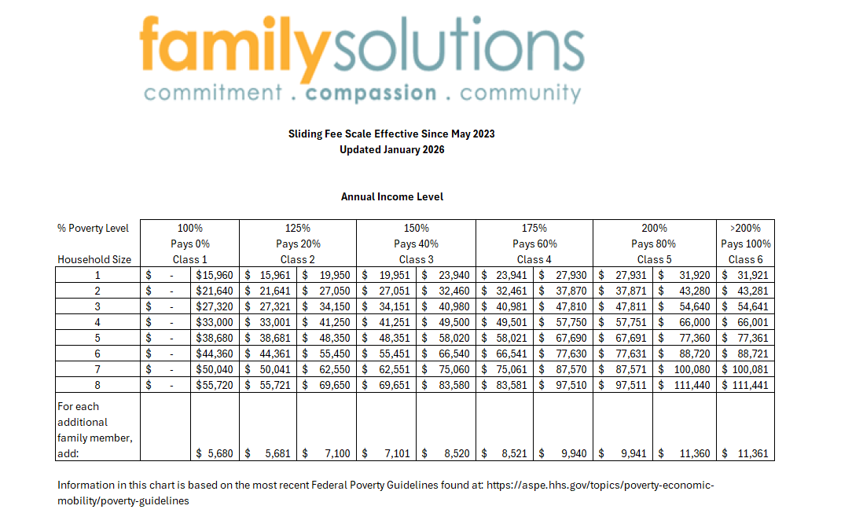

Origination | 5/20/2023 | Approved by Owner, Chris Faulkner
Last Approved | 5/20/2023 | Approved by Owner, Chris Faulkner
Effective | 5/20/2023 | Approved by Owner, Chris Faulkner
Previous Revision | 3/7/24 | Approved by Owner, Chris Faulkner
Last Revised | 5/23/25 | Approved by Owner, Chris Faulkner
Next Review | 5/19/2026 | Approved by Owner, Chris Faulkner
Last Revised | 5/19/2026 | Approved by Owner, Chris Faulkner

